Department of Computer Science

The City College of CUNY

CSc 22100: Software Design Laboratory [Fall 2019]

Exercise 3

*A printout showing the problem, solution method, codes developed, and outputs produced for the tests indicated is due during and before the end of the class on Thursday,* 14 *November* 2019*. The deadline is strictly observed.*

*A demonstration of your application is required.*

1. Implement a Java class **PieChart** that displays a pie chart of the probabilities of the *n* most frequent occurrences of an event to be specified in part 4 of the exercise. The probability of event is given by the equation:

$$Probability of event=\frac{Frequency of event}{\sum{Frequencies of all events}}$$

In the pie chart:

* 1. The area of each segment is proportional to the probability of the corresponding event:
 $$Probability of event=\frac{Central angle of segment}{2π}$$

 2. Each segment has a different color;
  3. Each segment has a legend showing the corresponding event and its probability;
  4. The segments are displayed in order of decreasing or increasing probability;
  5. The last segment represents “All Other Events” and their cumulative probability. As an example, in the graph below where the event is the occurrence of a letter in a text: *n* = 3, and the probability of All Other Events is *one* minus the sum of the probabilities of events *e*, *s*, and *i*;

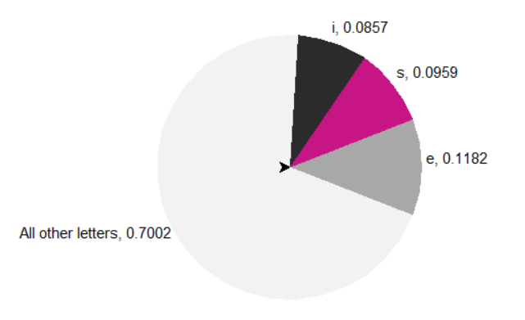

1. The **PieChart** class includes appropriate constructors and a method *draw* that draws the pie chart. The drawing canvas should include appropriate GUI components to input the number of events, *n*, and display the pie chart together with the events and their corresponding probabilities.
2. You may amend and use the class hierarchy in previous exercises, but in any case you may only use JavaFX graphics and your own classes and methods for the operations included.
3. Implement a Java class **HistogramAlphaBet** that calculates the *n* most frequent alphabet characters in “Emma” by Jane Austen (file *Emma.txt*) and their probabilities. The **HistogramAlphaBet** class utilizes a map collection for statistical calculations and the drawing canvas above to draw a pie chart of the probabilities.

Hesham A Auda

4 November 2019